**Evaluation Only. Created with Aspose.Words. Copyright 2003-2011 Aspose Pty Ltd.**

**Site acessado com sucesso**

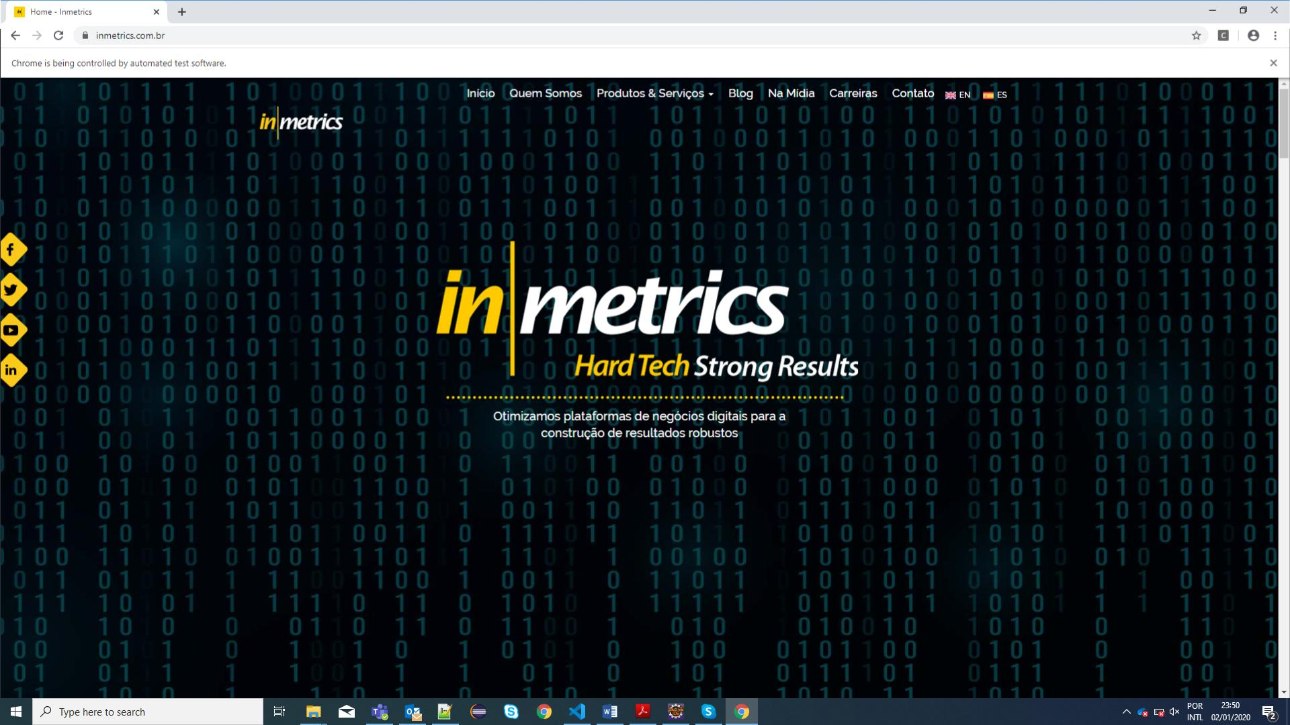

**Buscando botao de consultar vagas**

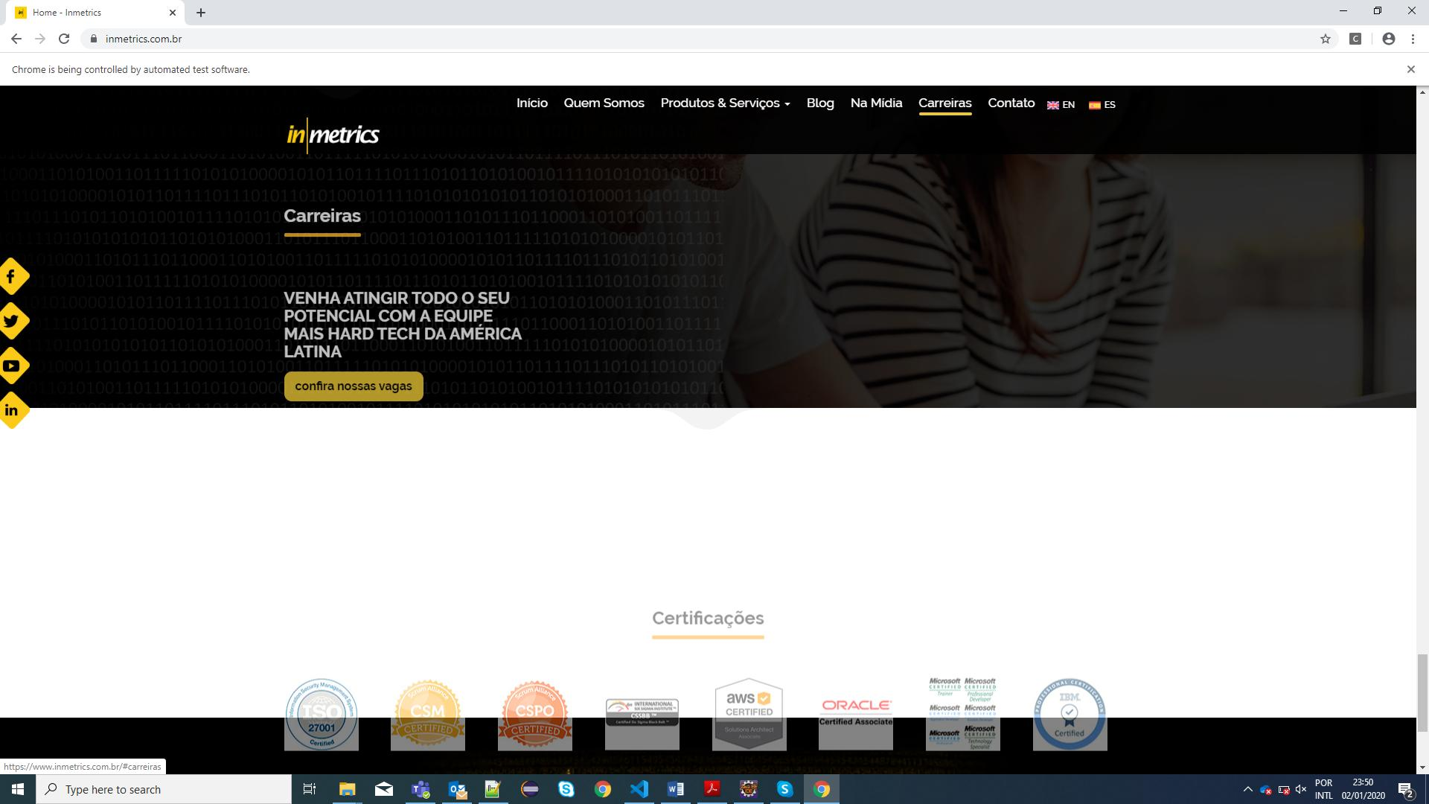

**Consulta de vaga realizada com sucessoEvaluation Only. Created with Aspose.Words. Copyright 2003-2011 Aspose Pty Ltd.**

